

UNDERGRADUATE PROJECT REPORT

|  |  |
| --- | --- |
| **Project Title:** | **Deep learning Application for the recognition of Breast Cancer** |
| **Surname:** | **Zhang** |
| **First Name:** | **Joseph** |
| **Student Number:** | **201918010314** |
| **Supervisor Name:** | **Dr. Grace Ugochi Nneji** |
| **Module Code:** | **CHC 6096** |
| **Module Name:** | **Project** |
| **Date Submitted:** | **May 5, 2023** |

**Chengdu University of Technology Oxford Brookes College**

**Chengdu University of Technology**

**BSc (Single Honours) Degree Project**

Programme Name: Computer Science

Module No.: CHC 6096

Surname: Zhang

First Name: Joseph

Project Title: Deep learning Application for the recognition of Breast Cancer

Student No.: 201918010314

Supervisor: Dr. Grace Ugochi Nneji

2ND Supervisor (if applicable): Not Applicable

Date submitted: May 5, 2023

*A report submitted as part of the requirements for the degree of BSc (Hons) in Computer Science*

*At*

**Chengdu University of Technology Oxford Brookes College**

# **Declaration**

**Student Conduct Regulations**:

Please ensure you are familiar with the regulations in relation to Academic Integrity. The University takes this issue very seriously and students have been expelled or had their degrees withheld for cheating in assessment. It is important that students having difficulties with their work should seek help from their tutors rather than be tempted to use unfair means to gain marks. Students should not risk losing their degree and undermining all the work they have done towards it. You are expected to have familiarised yourself with these regulations.

<https://www.brookes.ac.uk/regulations/current/appeals-complaints-and-conduct/c1-1/>

Guidance on the correct use of references can be found on www.brookes.ac.uk/services/library, and also in a handout in the Library.

The full regulations may be accessed online at <https://www.brookes.ac.uk/students/sirt/student-conduct/>

If you do not understand what any of these terms mean, you should ask your Project Supervisor to clarify them for you.

**I declare that I have read and understood Regulations C1.1.4 of the Regulations governing Academic Misconduct, and that the work I submit is fully in accordance with them**.

Signature: Joseph Zhang Date: May 5, 2023

REGULATIONS GOVERNING THE DEPOSIT AND USE OF OXFORD BROOKES UNIVERSITY MODULAR PROGRAMME PROJECTS AND DISSERTATIONS

Copies of projects/dissertations, submitted in fulfilment of Modular Programme requirements and achieving marks of 60% or above, shall normally be kept by the Oxford Brookes University Library.

**I agree that this dissertation may be available for reading and photocopying in accordance with the Regulations governing the use of the Oxford Brookes University Library.**

Signature: Joseph Zhang Date: May 5, 2023

# **Acknowledgment**

This report would not be possible without the Dr. Grace Ugochi Nneji, for which she provide the advice of the guide, ethnic and foundational work in the report writing process. Then the OBU computing school of Computer Science provide the support of the report. Besides, the Oxford Brookes University and Chengdu University of Technology provide the information of complete the report. Finally, without the family member support, the report will meet more difficult in the education.

# **Table of Contents**

**Declaration** ii

**Acknowledgment** iii

**Table of Contents** iv

**List of Figures** vi

**List of Tables** vii

**Abstract** viii

***Keywords:*** viii

**Abbreviations** ix

**Glossary** x

**Chapter 1 Introduction** 1

**1.1** **Background** 1

**1.1.1 Challenge** 2

**1.2** **Aim** 2

**1.3** **Objectives** 2

**1.4** **Project Overview** 2

**1.4.1** **Scope** 2

**1.4.2** **Audience** 2

**Chapter 2 Background Review** 4

**2.1 Summary of Related Literature** 4

**Chapter 3 Methodology** 8

**3.1 Dataset** 8

**3.1.1 Data Processing** 9

**3.1.1.1 Balance Class** 9

**3.1.1.2 Resize** 10

**3.1.1.3 Transform** 10

**3.2 Model** 11

**3.2.1 AlexNet** 11

**3.3 Performance Metric** 12

**3.4 Technology** 14

**3.5 Project Version Management** 14

**Chapter 4 Result** 15

**4.1 Hyperparameters** 15

**4.2 Evaluation of AlexNet** 15

**4.2.1 Accuracy** 15

**4.2.2 Loss** 16

**4.2.3 Confusion Matrix** 17

**4.2.4 Precision, Recall and F1 Score** 18

**4.3 GUI** 19

**4.4 Comparison Analysis with Other State-of-the-art models** 21

**Chapter 5 Professional Issues** 23

**5.1** **Project Management** 23

**5.1.1** **Activities** 23

**5.1.2** **Schedule** 24

**5.1.3** **Project Data Management** 24

**5.1.4** **Project Deliverables** 24

**5.2** **Risk Analysis** 24

**5.3** **Professional Issues** 25

**5.3.1 Ethical Issues** 25

**5.3.2 Legal issues** 26

**5.3.3 Environment issues** 26

**5.3.4 Social issues** 27

**Chapter 6 Conclusion** 28

**References** 30

**Appendices** 32

# **List of Figures**

Figure 3-1. The IDC class image for model…………………….....……………………………………9

Figure 3-2. The rate of the image should be flip…………………………………………….………..11

Figure 3-3. The figure of the model layer information……………………………………….……….12

Figure 4-1. The accuracy information in training……………………………………….…………….16

Figure 4-2. The loss information in training………………………………………………….………..17

Figure 4-3. The confusion matrix information……………………………………………..………….18

Figure 4-4. The initial GUI…………………………….…………………….…..............…….……….19

Figure 4-5. The dialog windows……………………………………………….........................……...20

Figure 4-6. The recognition result of the positive image…………………………………….….……21

Figure 5-1. The Gantt chart of the activities schedule…………………...……….…………………..23

# **List of Tables**

Table 2-1 Brief summary of all state-of-the-art related work..........................................................6

Table 3-1. The positive and negative of IDC image rate.................................................................9

Table 3-2. The split ratio of the model...........................................................................................10

Table 3-3. The table of the model layer information......................................................................12

Table 3-4. The technology information of the project....................................................................14

Table 4-1. The hyperparameters information of the model in training process..............................15

Table 4-2. The precision, recall and F1 score information............................................................18

Table 4-3. The compare result of State-of-the-art models……………………………………….…..22

# **Abstract**

Deep learning is popular approach for the recognition of breast histopathology image tasks, with a high accuracy efficiency in its recognition rate. Amongst the deep learning categories, Convolutional Neural Network (CNN) have been the trending subpart of deep learning models utilized in medical image diagnosis and analysis. Additionally, Invasive ductal carcinoma (IDC) is the common type of the breast cancer which is a harmful disease to the female sex. Therefore, there is need to reduce the immortality rate by introducing an automated system can effectively help to detect this disease at the early stage. This project will introduce AlexNet model for the distinct extraction of features and classification of breast cancer.

The dataset used in this work is breast histopathology pathology which contains 42063 images and the project evaluate the model with a split ratio set of 82% for training and 18% for testing. More so, the project model achieves a performance of 81.9% in accuracy. Besides, the project result shows that the proposed model is able to outperform some deep learning algorithms. Additionally, this project designs a GUI to input the image of IDC and identify the result correctly which can be introduced to medical practitioners as this will save time and resources for them.

***Keywords:***

Breast cancer, histopathology, recognition, CNN, AlexNet

# **Abbreviations**

IDC: Invasive Ductal Carcinoma

CNN: Convolutional Neural Networks

CPU: Central Processing Unit

GUI: Graphical User Interface

GPU: Graphics Processing Unit

ROC: Receiver Operating Characteristic

AUC: Area Under Curve

APS: Average Precision Score

IDE: Integrated Develop Environment

CUDA: Compute Unified Device Architecture

CuDNN: CUDA Deep Neural Network

AMD: Advanced Micro Devices, Inc.

NVDIA: NVIDIA Corporation

PNG: Portable Network Graphics

JSON: JavaScript Object Notation

# **Glossary**

Deep learning – An education side of machine learning, which make computer learn the data regular and layers to make artificial intelligent own analysis learning ability and recognition the image, voice and word information.

Image recognition – Using the computer to recognize the character of image to detect the image for analysis.

Breast cancer – A cancer of the mammary gland, which is the common cancer of female.

IDC (Invasive ductal carcinoma) - A common type of the breast cancer

CNN(Convolutional Neural Networks) – A class of including convolutional calculation and deep structure feedforward neural networks

Model – A structure of the neural networks

Alexnet – A model of CNN, which widely used to image detection

GUI(graphical user interface) – A user interface by using graphical way to allow the use input and get information from software

GPU(graphics processing unit) – A microprocessor for dealing with the image on desktop

IDE(Integrated Develop Environment) – A application for providing the program develop environment.

Pytorch – An open source python machine leaning library.

Kaggle – A platform of the data science competpetition, which can provide many dataset for deep learning.

Batch size – A size of the sample book from dataset for once train

Epoch – A turn of all dataset complete training

Loss – A value for calculate the result of the model predict result and reality result.

ROC(receiver operating characteristic curve) – The curve of false positive rate and positive rate.

AUC(area under curve) – The area under the curve of ROC

APS(average precision score) – The area under the recall-precision curve

Accuracy – A rate of the correct predict result in all predict result.

Precision – A rate of the correct true predict result in all true predict result.

Sensitivity - An available of define disease of a model when the disease appeared.

F1-score – A weighted average of precision and recall, which figure the precision and recall and keep them in balance.

GitHub – A version manage tool.

CUDA: A general-purpose parallel computing architecture introduced by NVIDIA.

CuDNN: A GPU acceleration library for deep neural networks.

AMD: A semiconductor company specializing in the design and manufacture of a wide range of innovative microprocessors as well as providing flash memory and low power processor solutions for the computer, communications and consumer electronics industries

NVDIA: An artificial intelligence computing company

PNG: A lossless compressed bitmap graphics format

JSON: A lightweight data exchange format

# **Introduction**

## **Background**

The breast cancer is a serious and famous disease of female. In fact, according to the Chaudhary and Qureshi and Rasul [1] the breast cancer occupy a quarter rate in the female life and the breast cancer also the most common cancer in female and the breast cancer is the second death reason. Therefore, the breast cancer detect and cure is important. In fact, the breast cancer cure result is depend on the breast cancer check. According to Nneji et al [2] although the breast cancer own several check way by using mammography and others, the cure result of breast cancer will be raised when the tumor is in the early stage and biopsy is the most authoritative way to check breast cancer. Of course, the biopsy need the medical officer use the microscope to check the histological slides and define the area cancer situation.

In fact, the identity of the Invasive ductal carcinoma (IDC) is the key of detect the breast cancer. As for the meaning of the IDC, Kanavati and Tsuneki [3] stated that IDC is the most common breast cancer and IDC is a group of the tumor that lack of the enough character to classification as a specific histopathological type and IDC own many histopathological characteristics such as the diffuse-sheets, well-defined nests, cords or single cell in the checking by using microscope. Besides, according to Chaudhury et al [4] the IDC can be detect by recognition the character of the nuclear morphometric features, which include about the size of the cell nuclear, regularity of nuclear margin and chromatin density. Thus, by using a deep learning model of IDC images recognition is possible and can be achieved.

In fact, Kanavati and Tsuneki [3] also noticed that the deep learning is own the widely used in the computational histopathology algorithms to detect the core needle biopsy specimens and deep learning is exist the example in breast histopathology Classification including the cancer cell classification and segmentation and predict the cancer patient core result and prognosis. In other words, the deep learn own the positive effect in the breast cancer recognition. In fact, according to the Kowal et al [5] computer-aided diagnosis is widely used to analysis the example of the core needle biopsy specimens, which can raise the accuracy of the recognition the image of positive and negative and break the limit of the professional officer. In other words, the deep learning can support the hospital to complete the IDC detect, which lack of the full experience and knowledge skill medical officer.

## **1.1.1 Challenge**

The model using the Pytorch frame for build the CNN model and the frame can also support the GPU for the model training. However, the frame need the CUDA platform and CuDNN accelerate toolkit for the GPU training process. These version of the support tool depend on the GPU driver version. In other words, the Pytorch frame code may have some issue of environment support. Besides, the AlexNet model is the multiple class classifier model by using two CPU to training model. In fact, the model just recognition the IDC image and just using one GPU in model training process.

## **Aim**

The project aim is to recognize invasive ductal carcinoma breast cancer images using deep learning model. In this project, the model is choose to using the AlexNet model of CNN.

## **Objectives**

1 Download the dataset for the model train and testing.

2 Build the CNN model for the image identify.

3 Successive training of the best model.

4 Checkmate and tweaking different hyper-parameters in the model

5 Evaluating the performance of the model by using different evaluation metrics such as accuracy, precision, F1-score and recall.

6 Build the GUI of identify the image by using the trained model.

## **Project Overview**

### **Scope**

The purpose of this study is to design an automatic system that will put together the advantage of deep neural networks for the recognition of Invasive Ductal Carcinoma (IDC) breast cancer images saving the medical practitioners time and resources and reducing death rate. The significant of this project study will assist breast surgeon in detecting breast cancer and specifying the proper treatment required. Patients will also benefit from this project research as it reduces their waiting/visiting time to seek for a medical breast surgeon.

### **Audience**

The targeted audiences are the medical breast surgeons and patients as it will reduce visiting hour, save time, lives and resources. In fact, the medical breast surgeons and patients require and meet is different. Besides, the target audiences are also own the different meet and benefit from the model of project.

About the medical breast surgeons, the medical officer should deal with the patient rapidly and get the cure way for the disease of the patient. Due to the cure of the disease is depend on the disease detection result, the disease detection is important for the medical breast surgeons to decide the cure way. Thus, the traditional recognition of the IDC breast cancer will waste the time and energy to detect the cancer. When the recognition image of IDC task is transfer to the artificial intelligent, the medical officer can use the energy to consider the cure way of the patient disease. Besides, some of the medical breast surgeons may lack the experience of detect the IDC. Thus, using the image recognition model to help doctor for detecting the IDC breast cancer can decrease the possibility of misdiagnose result.

As for the patient, the IDC breast cancer patient should know the cancer situation rapidly and accurately. When the hospital should deal with large of the patient for check the breast cancer, the patient may get the long appointment of the breast cancer check. Because the medical breast surgeons of hospital may busy to detect the microscope slide of the patient. When the model of IDC breast cancer recognition is using for the breast cancer task, the press of the hospital can be decreased and the patient can get the check result rapidly. In fact, many of the patient wish their cancer can be cured and the breast cancer situation is enough accuracy. So using the IDC image recognition model to help the medical breast surgeons to detect the microscope slide of the breast cancer cell can decrease the workload of the doctor and provide the refer recognition result to help doctor consider the patient breast cancer. When the medical breast surgeons is transfer to attention to the patient, the cure result and the recognition result can be get more accuracy.

# **Background Review**

**2.1 Summary of Related Literature**

Numerous researches have been analyzed with different CNN models which will be discussed in this section. Nneji et al. [2] focus on the model that using the siamese convolutional neural network to build the super-resolution generative adversarial network for classification the breast cancer and the model own 98.87% accuracy and own the 98.76% ROC-AUC scores on BreaKHis dataset identify. Besides, Kanavati and Tsuneki [3] train the whole slide image (WSI) classification models of the IDC breast cancer by using the transfer learning and weakly-supervised learning and in the one biopsy set and three surgical sets the ROC and AUCs is located in 0.95 to 0.99. Besides, the model is also used to compare the pre-train models of adenocarcinoma classification and the AUC score is from 0.66 to 0.89. Another authors, Spanhol et al. [6] reported a dataset from the 7909 person dataset of the breast cancer including the benign and malignant images and build an evaluation utilizing six different models for feature extraction and classifiers and achieved accuracies from 80% to 85%. In fact, Jadah et al. [7] used the dataset of the BreakHis images dataset and modify the parameter of the model to improve the model recognition and classify ability of AlexNet model of CNN. At the end of the training, the AlexNet model achieve the 96% accuracy result and the accuracy own the raise are by change the parameters and weights in multiple trying. Besides, Kumar et al. [8] provide CNN module for detect the IDC breast cancer area in the whole slide images of the breast. This educator compare several CNN model including the VGG16, VGG19, Xception, Inception V3, MobileNetV2, ResNet50 and DenseNet and using the dataset of 163 patient of IDC to train and test the model. In fact, the 113 images for train and 49 images for test and the model achieve 83% accuracy and higher than other model’s accuracy. In fact, Hou [9] get a CNN model to classify the breast cancer by using the pathological images. The model using the data strength and transfer learning way to avoid the model meet the overfit situation in the training process. When the model using the BreaKHis dataset for training, the accuracy achieved the 91% and the new model own the robust and generalization ability compare with the original CNN model for image classfication. Albashish et al [10] find a CNN model, which depend on the VGG-16 and using the 16 layers transfer learning to train the dataset of the BreaKHis. Then the model is own the binary class and eight class to deal with different breast cancer classification task. In fact, the compare with the other pre-train model including VGG-16 and AlexNet the binary class model get the 96.0 $±$ 2.20% accuracy result. However, Khairi et al. [11] fully compare the CNN model of AlexNet, GoogleNet and ResNet 18 of deal with the classification on the histopathology images on the breast cancer by using the BreakHis database to get the breast cancer image, which all images are 7,909 images including 2,480 benign and 5,429 malignant images. Then get the best result in the ResNet 18 that accuracy is 94.8% in 70 min 31 sec and the AlexNet and GoogleNet have 91.6% and 87.6% accuracies and 927min 38sec and 71 min 4 sec times. Then the report also compare about the different measurement metrics including accuracy, sensitivity, specificity and F-Score of the models in different magnification levels. In fact, the comparison study of three model is completed, with increase of the magnification the accuracy is raise and in the 400X the ResNet 18 that accuracy is 98.4% and the AlexNet and GoogleNet have 97.3% and 95.8% accuracies. Golatkar and Anand and Sethi [12] provide a CNN model by change the Inception-v3 convolutional neural network and classify the breast cancer in the H and E stained breast tissue images. In fact, these images is divided to four class of the beast images the normal tissue, benign tumor, in-situ carcinoma and invasive carcinoma. About the result of the model classify result, the model get the accuracy of 85% about the average four class and get 93% accuracy of the non-cancer class and carcinoma class. Shallu [13] is using VGG16, VGG19, and ResNet50 to show the ability of transfer learning in the histopathological image and analysis the model classification behavior in different magnification then the VGG16 get 92.60% accuracy, 95.65% AUC and 95.65% APS in 90–10 training–testing data splitting. Besides, the Cruz-Roa et al [14] evaluate an image identify model of using the deep learning in the invasive tumor arrange image accuracy and robust. Their model nearly 400 examples to train their model and get the 75.86% Dice coefficient, positive predictive value of 71.62% and negative predictive value of 96.77% in the analysis of the pixel to pixel way of the invasive tumor images. As for the X-ray image of the breast cancer, Yuan et al. [15] build a CNN classifier to decomposition the texture images of the breast cancer to 8 bit-plane images for provide different character to the images for classification and get the twenty five feature subgraphs from the images. By using VGG16 network and the accuracy is raised from 63.5% to 91.1%. In fact, same with the education of the X-ray image, Mahmoud and Alharbi and Alghamdi [16] stated a classification system for the breast cancer tumors, which using the CNN to get the character of the images. In fact, the dataset using 600 female breast X-ray check images and get the 98.53% accuracy of the cancer detection, 95.6% accuracy of the benign detection and the 95% for the normal cases. Then about the thermal images, Zuluaga-Gomez et al. [17] establish a self CNN model by get the more robust result and get the 92% accuracy, 94% precision, 91% sensitivity and 92% F1-score in fifty five patients database better than the ResNet50 and SeResNet50 model. In other words, the model by using the data-augmentation achieved same ability with other that using the large dataset to train the model.

|  |  |  |
| --- | --- | --- |
| Researchers | Model | Performance |
| Nneji et al. [2] | Siamese convolutional neural network | Accuracy = 98.87%  ROC-AUC scores = 98.76% |
| Kanavati and Tsuneki [3] | Whole slide image (WSI) classification models | ROC, AUCs = 95% |
| Spanhol et al [6] | Different CNN architecture | Accuracy = 80% |
| Jadah et al. [7] | AlexNet model | Accuracy = 96% |
| Kumar et al. [8] | CNN model | Accuracy = 83% |
| Hou [9] | CNN model | Accuracy = 91% |
| Albashish et al [10] | Binary class model depend on VGG-16 | Accuracy = 96.0 2.20% |
| Khairi et al. [11] | AlexNet, GoogleNet and ResNet 18 model | ResNet 18  Accuracy = 94.8%  AlexNet  Accuracy = 91.6%  GoogleNet  Accuracy = 87.6% |
| Golatkar and Anand and Sethi [12] | CNN model by change the Inception-v3 convolutional neural network | Average four class  Accuracy = 85%  Non-cancer class and carcinoma class  Accuracy = 93% |
| Shallu et al. [13] | VGG16, VGG19, and ResNet50 model | Accuracy = 92.60%  AUC = 95.65%  APS = 95.65% |
| Cruz-Roa et al [14] | Self CNN model | Dice coefficient = 75.86%  Positive predictive value = 71.62%  Negative predictive value = 96.77% |
| Yuan et al. [15] | VGG16 model | Accuracy = 91.1% |
| Mahmoud and Alharbi and Alghamdi [16] | Self CNN model | Cancer detection  Accuracy = 98.53%  Benign detection  Accuracy = 95.6%  Normal cases = 95% |
| Zuluaga-Gomez et al. [17] | Self CNN model | Accuracy = 92%  Precision = 94%  Sensitivity = 91%  F1-score = 92% |

Table 2-1 Brief summary of all state-of-the-art related work

# **Methodology**

In fact, the literature review of the project about the image recognition of the medical disease in breast cancer tumor detection is including the X-ray and histopathological image. Of course, the model should use the biopsy tissue section of the breast cell for image recognition and the dataset is binary class of the recognition result. In fact, the project is provide an image recognition model depend on the AlexNet and the image is from the biopsy tissue section of the breast cell.

## **3.1 Dataset**

The project using the images form the breast histopathology pathology and the image own the two class of the IDC of breast cancer. The dataset is the Invasive Ductal Carcinoma (IDC) image of the breast cancer and the dataset is divided to two classes of the IDC state, which IDC state are positive and negative. The breast histopathology pathology own the 277,524 image patches with 50x50 size from the 162 whole mount slide images of Breast Cancer specimens in the 40 multiplying power, including the 198,738 IDC negative image patches and 78,786 IDC positive image patches. In fact, the images is using to train and validate the model for the image recognition and the character of the IDC class show be provide to the CNN model for the image recognition. Thus, these are the figure of the dataset and each images are the class of the IDC. In fact, the figure is from the breast histopathology pathology dataset and the image is the Invasive Ductal Carcinoma (IDC) breast histopathology pathology.

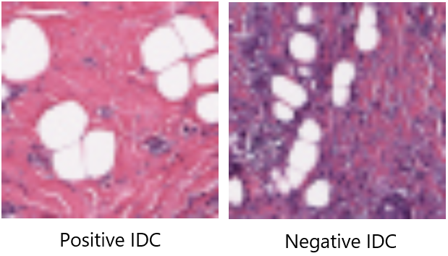

Figure 3-1. The IDC class image for model

## **3.1.1 Data Processing**

## **3.1.1.1 Balance Class**

In fact, the breast histopathology pathology dataset own the two classes of the IDC and the image number of the each class is not balance. The dataset own the 198,738 IDC negative image patches and 78,786 IDC positive image patches, which rate of two class is 11041:4377 and the percentage is over the 71.6%. Thus the dataset image for model train and model validate should be balanced. In fact, the model just use part of the IDC image from the breast histopathology pathology dataset and the positive class used the 21789 images and the negative class used the 20274 images. The percentage rate of the IDC class is the 51.8% and the class of the dataset is balanced.

|  |  |  |  |
| --- | --- | --- | --- |
|  | Positive IDC | Negative IDC | Percentage Rate |
| Breast Histopathology Pathology Dataset Images | 78,786 | 198,738 | 71.6% |
| Balanced Dataset Images | 21789 | 20274 | 51.8% |

Table 3-1. The positive and negative of IDC image rate

## **3.1.1.2 Resize**

Besides, the breast histopathology pathology dataset own the image of IDC and the images is the biopsy image of the pathological tissue sections. In other words, the image is from the 162 whole mount slide images of Breast Cancer specimens in the 40 multiplying power and the size is not fit require the model. So the image should change the size from 50x50 pixel to the 224x224 pixel for the model training and testing. Besides, the spilt ratio of the dataset is divided to the 34523 images for training and 7540 images for validation. These total of the spilt ratio is 82% of the train and test rate.

|  |  |  |  |
| --- | --- | --- | --- |
| Dataset | Train image | Test image | Total |
| Balanced Dataset Images | 34523 | 7540 | 82% |

Table 3-2. The split ratio of the model

## **3.1.1.3 Transform**

The image of the dataset is changed to the model for training and validating. However, the image recognition model should deal with some specific situation in the medical breast cancer IDC recognition. Thus the IDC image of the model training use the data strength in the image data loader and the data strength is using the flip method of the images. In the data loader for the training, the 50% percentage of the IDC image patches should be horizontal flip in the train process. Thus, if the cell of the breast histopathology pathology used in the opposite, the model can recognition the character of the IDC.

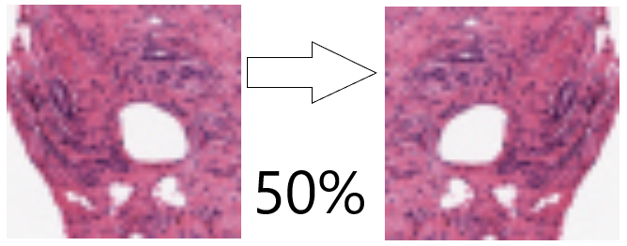

Figure 3-2. The rate of the image should be flip

## **3.2 Model**

## **3.2.1 AlexNet**

The model in the image recognition is using the AlexNet model structure to help build the model for image recognition. Although the AlexNet is using the 5 convolution layers and 3 full connected layers, the model should follow the structure of the AlexNet. However, different with the AlexNet model the model for the IDC image recognition is the binary class model. Thus, the classifier of the model just notice two character graph of the IDC. Besides, the model using one GPU to train the model for image recognition and the layer size is depend on the AlexNet. In fact, the model is start at the 224x224x3 convolution layers, which 224 pixel size is the AlexNet begin layer size and 3 depth include the RGB color in the images. Then 48 kernel is used in the convolution layer of image and the pooling layer can use the max pooling method to change the size to 27x27. Then the next convolution layer in 128 kernel and pooling layer in max pooling method can change the size to 13x13 pixel. Then the three convolution layers in the next convolution figure, the kernel number are 198 and 128. Then at the end of the convolution layers the max pooling layer should pooling the size to 6x6 pixel. Thus, the full connected layer should classify the class of the character. In the first full connected layer, the number is 2048 by multiple the length, width and depth of the pooling layer output layer. Then the full connected layer should drop the 0.5 number in the first and second layers, according to the AlexNet structure. Finally, in the last full connected layer, the number of the character should figure in two class for the classifier the IDC image positive and negative.

|  |  |  |  |
| --- | --- | --- | --- |
| Layer | Size | Special | Kernel Number |
| Convolutional Layer | 224x224x3 | Relu Layer | 48 |
| MaxPooling Layer | 55x55x48 | Max Pooling Method |  |
| Convolutional Layer | 27x27x48 | Relu Layer | 128 |
| MaxPooling Layer | 27x27x128 | Max Pooling Method |  |
| Convolutional Layer | 13x13x128 | Relu Layer | 198 |
| Convolutional Layer | 13x13x198 | Relu Layer | 198 |
| Convolutional Layer | 13x13x198 | Relu Layer | 128 |
| MaxPooling Layer | 13x13x128 | Max Pooling Method |  |
| Full Connected Layer | 2048 | Drop Out 0.5 |  |
| Full Connected Layer | 2048 | Drop Out 0.5 |  |
| Full Connected Layer | 2048 |  |  |

Table 3-3. The table of the model layer information

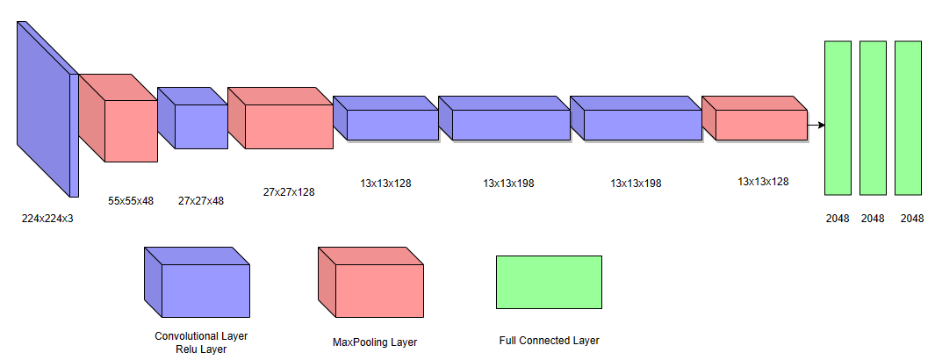

Figure 3-3. The figure of the model layer information

## **3.3 Performance Metric**

The model of the image recognition should be evaluate by using some common performance metric of the deep learning model. The model using the accuracy and the loss of the model in the train process to consider the model of each epoch result. As for the figure process of the accuracy, the model figure the accuracy by the recognition result of the model. In fact, the accuracy is the rate of the model get the correct recognition result of the all recognition result. By figure the accuracy of the model in each epoch, the model can get the result in the model training. Then the accuracy is also the metric of evaluation the model recognition skill of correct recognition.

$$Accuracy=\frac{(TP+TN)}{(TP+TN+FP+FN)} Equation(1)$$

Besides, the model use the cross entropy way to figure the loss in the model training. The cross entropy is widely used to figure the part of the real probability distribution and calculate probability distribution in the deep learning model. The smaller figure value of the cross entropy, the better image recognition model precision result.

$$H\left(p,q\right)=-\sum_{i=1}^{n}{p\left(x_{i}\right)\log\left(q\left(x_{i}\right)\right)} Equation(2)$$

Of course, the model should use the precision and recall for evaluation the model other recognition ability for the image recognition the IDC. At firstly, the accuracy just show the model recognition ability of the correct recognition. When the ask ability of the model should get the correct recognition result in the positive IDC class, the recall and precision should be used in the evaluation of the model. The recall is the model recognition result, choice the correct recognition result and rate to the positive class result. Then the precision is get all of the positive recognition result and get the correct positive result to get the rate with them. Of course, the recall and precision show an extreme side of the model in the image recognition. Thus, the F1 score should use to get the harmonic average of the precision and recall. In other words, the F1 score get the same weight of the precision and recall in the F $β$ metric and the F1 score is shown the model average metric of the precision and recall.

$$Recall=\frac{TP}{\left(TP+FN\right)} Equation(3)$$

$$Precision=\frac{TP}{\left(TP+FP\right)} Equation(4)$$

$$F1 Score=\frac{2×Precision×Recall}{\left(Precision+Recall\right)} Equation(5)$$

## **3.4 Technology**

The project is depend on the hardware and software for build and train the model for image recognition. The language for the image recognition model is using the Python language and the framework for the model is the Pytorch framework and library. Of course, the GUI for the predict result is using the package Tkiner GUI from the Python and the IDE for build the model code is Pycharm. Then due to the model should use the GPU for deal with the image recognition task and use CPU for draw the diagram of performance metrics. The GPU is using the NVIDIA GeForce 940MX for train and validate the model and the NIVDIA GPU can support the library of the CUDA and the spread toolbox CuDNN. Besides, the CPU is using the Intel(R) Celeron(R) CPU 3965U @ 2.20GHz for deal with the number figure work and the CPU still can replace the GPU for train the model in the special situation. As for using the Pytorch of Python to build the model, the Pytorch is a common library for train the model of CNN and the Pytorch own the AlexNet model for transfer learning. In fact, the model can build in the environment of the table and the model can set in the other desktop with the similar environment.

|  |  |
| --- | --- |
| Type | Content |
| Framework | Pytorch |
| Language | Python |
| GUI model | Python Tkiner GUI |
| IDE | Pycharm |
| Central processing unit (CPU) | Intel(R) Celeron(R) CPU 3965U @ 2.20GHz |
| Graphic Processing Unit (GPU0) | NVIDIA GeForce 940MX |

Table 3-4. The technology information of the project

## **3.5 Project Version Management**

The version can use the GitHub desktop to link to the Git repository and create the project in the GitHub.com to store different vision project documents file. In fact, the desktop can also keep the project file in different vision. The website link of the model for training and testing in the GitHub is https://github.com/JosephMajZ/Project_IDC_CNN.

# **Result**

# **4.1 Hyperparameters**

When the model is completed the training and validating, the hyper parameter should be get from the model information. Of course, the model is a CNN model depend on the AlexNet. Thus, the model use the gradient descent method for figure the loss for the model. So the hyper parameter of the model is based on it. At first, the model image size should start at the 224 pixel size for fit the start convolution layers and the data loader should use two for the train dataset and validate dataset. Then the batch size of the data loader is different, the train data loader is 32 and the validate data loader is 4.The train and validate process epoch is 10, which means the model should train the dataset in 10 times and choice the highest result for update the model. Of course, the model initial learning rate should keep in the 0.0002 and the number of class is 2. Besides, the model can use the JSON file to store the information of the classify result, which positive IDC class is 1 and negative class is 0.

|  |  |
| --- | --- |
| Hyperparameters | Value |
| Image Size | 224x224 |
| Data Loader Number | 2 |
| Train Data Loader Batch Size | 32 |
| Validate Data Loader Batch Size | 4 |
| Epoch | 10 |
| Initial Learning Rate | 0.0002 |
| Class Number | 2 |

Table 4-1. The hyperparameters information of the model in training process

# **4.2 Evaluation of AlexNet**

# **4.2.1 Accuracy**

The model is get the accuracy of the model in the train of the image recognition. In fact, when an epoch train is completed the train accuracy and validate accuracy should be get in the end of the epoch In fact, the accuracy show the model predict ability of the model image recognition. Then the trend of the train and validate accuracy can also show the process of the model train. In fact, the model actuary curve is keeping raise and the validate curve occupy the undulate in the train process. Of course，the undulate in the curve is normal and the epoch is short to increase the variance of the validate accuracy result. In fact, the accuracy of validate is keep on increase trend. Besides, the validate accuracy is lower than the train accuracy. Perhaps the train occupy the over fit in the training. However, the model still achieve the 84.7% accuracy in the training process.

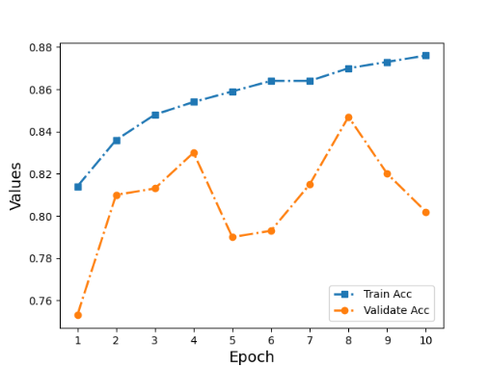

Figure 4-1. The accuracy information in training

# **4.2.2 Loss**

Then the model of the loss is use the cross entropy method to figure out the loss in each of the epoch. In fact, the loss of the train is descent in the train process. Although the validate loss occupy the undulate situation in the epoch validate process, the trend of the loss curve still keep the decent. Perhaps, the batch size of the validate data loader is small or the initial learning should be decreased. Of course, the loss of the validation is less than the train loss, which means the model can fit the image recognition task of recognition IDC.

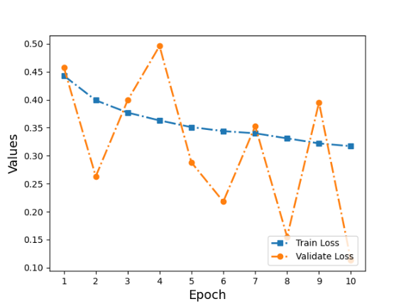

Figure 4-2. The loss information in training

# **4.2.3 Confusion Matrix**

The confusion matrix is the predict result of the model in the test image of the true images. The result of the classify result of the IDC classes is shown of the positive and negative result and the predict result is including the true and false result. In fact, the confusion matrix result is including the binary class of the IDC positive and negative to the model for predict. Then the other performance metric values can be figured by using the value from the confusion matrix.

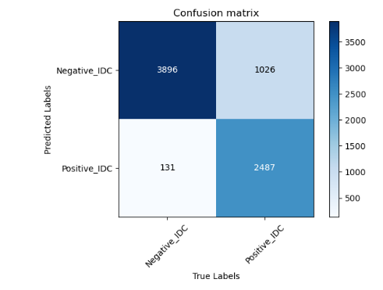

Figure 4-3. The confusion matrix information

# **4.2.4 Precision, Recall and F1 Score**

The confusion matrix shown the result of the model predict result of the image for testing. The precision shown the model for get the correct result in the positive result and the model get the 95.0% on it. Then the recall show the model get the positive result in the all correct predict result and the model get the 39.0%. In fact, the model trend to recognition the IDC to negative and it may cause the misdiagnose event. Of course, the F1 Score should be figured by using the precision and recall value. The value of F1 Score is 55.3% and the F1 score get the objective value in the model evaluation.

|  |  |
| --- | --- |
| Performance Metric | Value |
| Precision | 95.0% |
| Recall | 39.0% |
| F1 Score | 55.3% |

Table 4-2. The precision, recall and F1 score information

# **4.3 GUI**

By using the tkinter, the windows of the GUI is presented. The windows can change the size in to the random size of the windows. The minimum size of the windows is just remain the title line and the title can also be ignored. If the medical officer want to change the size of the windows, just like other windows software the medical officer should put the mouse in the each line of the windows and drag it to change the size. Similar with change the size, the windows can be move by click and drag. Of course, the button in the title line can be work normally, the minimum button can be implement the function of minimum the windows, the maximum button can implement the function of maximum the windows and the close button can close the windows and stop the program of the GUI. In fact, the image of the IDC breast cancer of need to recognition the positive and negative IDC by using the model can be choice by click the open button.



Figure 4-4. The initial GUI

When click the Open button in the GUI by making with tkinter, a new windows is created by choose the IDC images to the model for predict the positive class and the negative class in the image recognition model. In fact, the GUI is using the filedialog function in the tkinter frame to create the windows to choose the single image in the desktop to input the image to the predict file. And the file will read the JSON file to know the classify standard and using the model to get the recognition result. In fact, by using the dialog windows, the medical can upload any images in the desktop and even the other device image that link to the desktop. Although the image for recognition should remember the directory of the images, the browser history is not changed. In other words, if the medical officer store the image file in the A folder directory, when the doctor completed the recognition image positive and negative IDC breast cancer task and close the windows of the GUI, the dialog directory is still keep in the A folder and the next image upload is start in the folder A. Besides, the file name can be searched in the dialog directory same with other folder. These design raise the effective of recognition the image and decrease the work, which is unnecessary. In fact, the dialog windows just show the image in the PNG type file, because the PNG file is the modified file type of the images. Due to the model is training by using the 40x slide and the image original size just only 50x50 pixels. The model must use the IDC breast cancer images by modify the size for training and validate. Thus, using the PNG type image file for recognition the positive and negative of the IDC breast cancer is fit for the model.

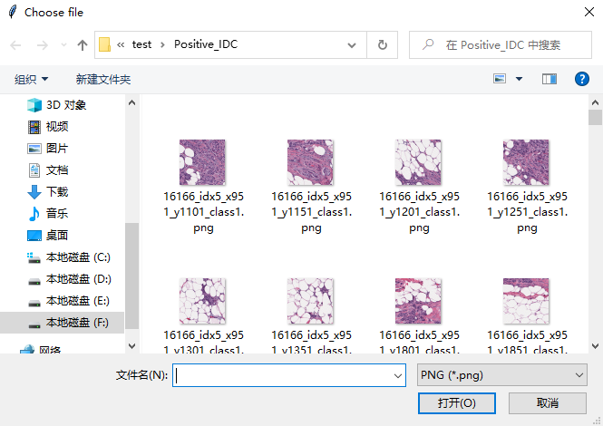

Figure 4-5. The dialog windows

When upload the image into the GUI, the GUI will get the name of the images and put the image file to the predict file. In the predict file, the file get the model result and the JSON classification standard to get the recognition result. In this situation, the GUI input a negative IDC breast cancer image for test the recognition function. Then when click the open button the dialog windows closed automatically and the GUI add the images in the windows. As for the recognition result, the label of a GUI get the recognition result the image and the label is output the recognition result by using the textbox. Of course, the name of the image cannot be used in the GUI including the recognition the IDC breast cancer positive and negative class and shown in the windows directly. As for the textbox, the label of the tkinter is not role the input task. Thus the context of the textbox cannot influence the results of the recognition images and every word in the textbox will be covered by next recognition result. Thus, the dialog upload the IDC negative class in the test dataset, after the image upload predict file get the recognition result and the image of IDC breast cancer recognition result and image for recognition put in the windows of the GUI. The image is the choice image in the dialog and the recognition image of IDC breast cancer positive and negative result is fit the negative class.

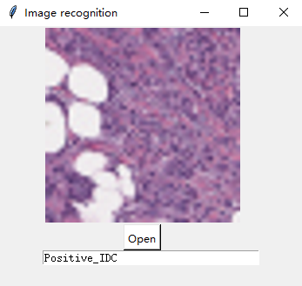

Figure 4-6. The recognition result of the positive image

# **4.4 Comparison Analysis with Other State-of-the-art models**

In fact, the model using the AlexNet model for the biopsy tissue section of the IDC. Then the model just recognition the IDC from the breast cell images. In other words, the model should compare with other model using the pathology image and the other model should use the binary class for classifier the IDC. In fact, the model is lower than other model in the accuracy. Especially, the model accuracy lower than the Jadah et al. [7] model, which also using the AlexNet model for image detection. Of course, the model can achieve higher accuracy by using other batch size for test dataset to solve loss curve fluctuation in the future work.

|  |  |  |
| --- | --- | --- |
| Researchers | Model | Performance |
| Spanhol et al [6] | Different CNN architecture | Accuracy = 80% |
| Jadah et al. [7] | AlexNet model | Accuracy = 96% |
| Kumar et al. [8] | CNN model | Accuracy = 83% |
| Hou [9] | CNN model | Accuracy = 91% |
| Albashish et al [10] | Binary class model depend on VGG-16 | Accuracy = 96.0 2.20% |
| Khairi et al. [11] | AlexNet, GoogleNet and ResNet 18 model | ResNet 18  Accuracy = 94.8%  AlexNet  Accuracy = 91.6%  GoogleNet  Accuracy = 87.6% |
| Shallu et al. [13] | VGG16, VGG19, and ResNet50 model | Accuracy = 92.60%  AUC = 95.65%  APS = 95.65% |
| This project work | AlexNet model | Accuracy = 84.7%  Precision = 95.0%  Recall = 39.0%  F1 Score = 55.3% |

Table 4-3. The compare result of State-of-the-art models

# **Professional Issues**

## **Project Management**

### **Activities**

1 Find the website of provide the require fitting dataset.

2 Download the fit dataset from the website.

3 Sort and check the dataset.

4 Download the related tool box and prepare the environment.

5 Define the logic of the model and find about the related recourse.

6 Coding the model in the Pycharm.

7 Import and train the model and get the weight and loss from last generation model.

8 Collect the loss from each generation model and draw chart to analysis the loss value.

9 Import the test dataset and get the result of recall, precision and accuracy.

10 Draw the precision-recall chart and figure out the F1-score of the model.

11 Complete the predict program for detect the image.

12 Complete the GUI for detect the image.

13 Write the progress project report and make the video of introduce project.

14 Test the model for get the best value

15 Write the abstract of the final project.

16 Write the Glossary, abbreviation and acknowledgement.

17 Write the first final report.

18 Write the Poster

19 Check the GUI of the project for the presentation

20 Join the presentation for the final report.

### **Schedule**

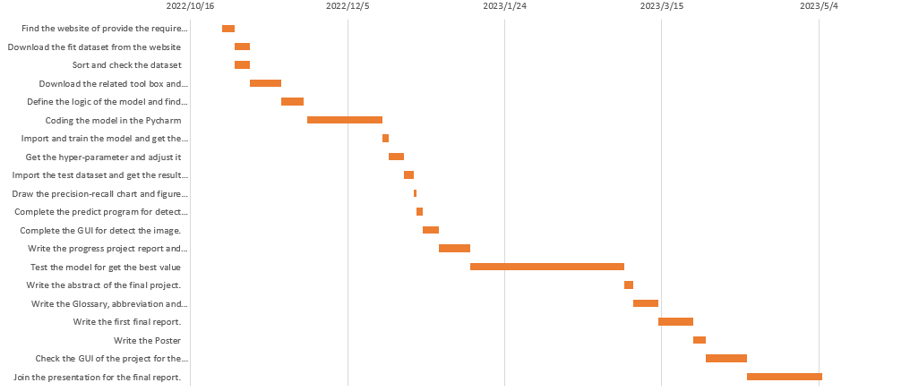

Figure 5-1. The Gantt chart of the activities schedule

### **Project Data Management**

Use the GitHub to make the program report and define the task for the project. These files will be stored in the same link of the model code and the document can be stored on line.

### **Project Deliverables**

The model of can identify the IDC image is built and the model can display the correct result about the positive or negative with patch. Then a GUI for use the image to detect IDC still will be implement. Besides, there are some text file will be submit.

For example, the poster, final project report, project presentation and weekly report. In fact, the presentation of the project will be considered, including project presentation’s PPT and project code. Then the GUI will become the important of the project presentation work.

## **Risk Analysis**

The project meet some risks in the project and the report will analysis the risk in the project progress developing. About the detail of the risks, the risks are show in table 2 in appendence. These risks in the figure is trying to exception in the developing. Then due to the environment support exception of the tensorflow module in developing progress, the module of build the Alexnet is change to Pytorch. Besides, the train code and validate of the Alexnet model provide the information for estimate the complete trained model. However, the information loss some parameters and the information is completed. Then the project should complete the report in the limit time. Thus the risk of the break time still important. Of course, the post and presentation of the project still should be completed. Besides, when the model is set in the hospital, the technical support the model is necessary and important. Perhaps, the software may meet bug or the pytorch version may not support the model. Thus, the environment of the model is necessary and important. Then the model lack the parameter of the precision and the recall value, if the model is used to research for other deep learning model of the image recognition, the researcher may meet the problem of compare with the other model. Besides, the model use the GPU to help the image recognition and raise the speed of the training, which model is depend on the Pytorch and the GPU should use the CUDA figure platform to support the GPU train. However, the CUDA is depend on the NVDIA graphics. In other words, if the desktop just own the AMD graphics or the integrated graphics such as the Intel Celeron, the model cannot use the GPU to help training. Although the model can support the CPU to train, it will waste too many times on it. Of course, the hospital desktop can use the hyper-parameter from the model training and use the pre-train model to complete the recognition task of the IDC breast cancer images. However, if other researcher want to use this model to train it, they may need to change other equipment for training.

## **Professional Issues**

The project is about the image recognition of the disease images. As is known to all, medical information is the individual privacy and the leakage of the image can cause legal, social and ethical issues. Then the project can provide a way to recognition the IDC image by using artificial intelligent, which might cause environment issues.

## **5.3.1 Ethical Issues**

The project uses the Ethics Review Form E1 and the project program can not cause the issue of the ethical issues. As for the Ethics Review Form E1, the table is refer to the University Code of Practice for the Ethical Standards for Research involving Human Participants, available at http://www.brookes.ac.uk/Research/Research-ethics/. Also, the dataset utilized is publicly available and has been referenced.

Besides, the project is about the medical image recognition model by using the CNN in deep learning in the artificial intelligent area. In fact, the medical and health information is the people private information. When the medical information of the patient be used to recognition the breast cancer of the patient by using the artificial intelligent, which whether means the artificial intelligent can ignore the others privacy when the situation is necessary. Of course, this project is not exist this issues because the project is just a tool to help the medical officer to recognition the breast cancer of the patient. In other words, the role of the disease recognition are medical officer and patient. As for the model of image recognition of IDC breast cancer for positive and negative, this model just a tool to help the medical officer to recognize the disease of the patient. However, this model may own the risk for abuse. If the patient get the model, they may trust the model recognize result than the medical officer. Of course, the model is recognize the biopsy slide of the breast cell and normal patient have not the ability to use the model to recognize their breast cancer. However, if the hospital trend to depend on the recognition result of the model, the ethical issues should be considered.

## **5.3.2 Legal issues**

The project just provide a way to detect the disease and the model accuracy cannot achieve the 100%, therefore the recognition result may cause the misdiagnose example in the disease detection. When the misdiagnose result is happened the response distribution is the main legal issues of the project. Although the misdiagnose result own several reasons, the model still have some risk to bear the responsibility. For decrease the legal issues, the hospital should use several way to detect the patient disease and notice the patient and their family member the risk of appear the misdiagnose result.

Then the project should use the artificial intelligent to recognition the image of IDC. Thus the patient breast scanner image and IDC recognition result should be stored and register to the medical record. In other words, the hospital own the patient private medical information. In the information leakage event, the model may cause a port to get the patient breast cancer recognition result. Thus, the model should set in the security desktop, which should link in the private local network.

## **5.3.3 Environment issues**

The project can save the professional medical officer time and raise the effect of detecting the patient disease, which may make hospital pay less medical resource of recognition image and disease the medical waste. However, the benefit may offset by other energy consumption. For example, the hospital may need use more electric energy to keep the electric equipment and the set of electric equipment may be cause pollution. Then the project follow the Ethics Review Form E1, which confirm the project could not cause the pollution.

In fact, the model of the image recognition of IDC breast cancer may provide more influence on the environment. In the breast cancer, there are several detect way for detecting the breast cancer tumor. For example, the X-ray, MRI, b-mode ultrasonography and biopsy. In fact, the biopsy is one way of recognition the breast cancer. However, the model of the image recognition of IDC breast cancer in positive and negative is depend on the biopsy slide. In other words, the model is encourage the biopsy way to recognition the breast cancer. As is known to all, the biopsy will produce more medical junk and this junk must be deal with carefully to prevent the pollute accident. Thus by using the model maybe equal to encourage hospital produce more medical junk. However, the biopsy is the most authority of detect the breast cancer way and the biopsy is necessary to check the situation of the breast cancer although the biopsy is also most extreme detect way for breast cancer.

Besides, the model is using the GPU for training the model in the Pytorch. However, the Pytorch need the graphics card to using the CUDA platform and CuDNN speed rapid tools. In other words, only the Nvidia graphics can find the environment of the model training, which means that if the researcher only own the AMD graphics card and other general graphics card they need to change a new desktop to continue the deep learning research work or change to the CPU to train the model and waiting for the train result in more times. In fact, either change a new desktop or waste more time and electric, these are all waste the resource. However, the situation may happen in the researcher who lack of the experience of deep learning. In other words, the waste is not a common situation.

## **5.3.4 Social issues**

The project can use the artificial intelligent to recognition the images. The technology is widely used to deal with several different tasks and the related education of use deep learning to recognition image in the medical area can also completed. Thus, the social may not extensive attention the technology in the project. Besides, the project is about the medical issues and more specifically the project is about the IDC image recognition. Thus, the social may argue about the rate of computer aided therapy in the breast cancer recognition should be taken. However, the project just provide a way to recognition the IDC image. Thus, the social influence might be positive.

In fact, the model should use the patient breast scanner image to recognition the IDC. Thus, the patient private information should lead to the social argument. In other words, the patient breast cancer scanner image may be used to train and validate the model. The private information leakage risk may aggravate social distrust of the medical project and even lead to the anti-intellectualism more prevalently. In fact, according to the Ethics Review Form E1, the project use the Breast Histopathology Images dataset from the dataset website and the image is upload by Mooney [18] in Kaggle website by the for research the IDC image recognition model. In other words, the project cannot offensive the patient private medical information and all image for model train and validation is open source.

# **Conclusion**

The deep learning of the image recognition is widely used in the different part of the social area. In this project, using deep learning to build a CNN model to recognition the image in the medical research is success. The project is about the deep learning model of the AlexNet model to recognition the images in the artificial intelligent. In fact, the model is provide a way to recognition the images of the IDC images in the breast cancer detection. Therefore the hospital can save the resource to recognition the image of the IDC and the hospital can raise the effective to detect the patient breast cancer to confirm the patient can get the cure in the cancer early stage. Besides, the model can break the limit of the professional officer limit and decrease the role of the officer.

This project keep the agile methodology to keep the code easy to management. Then the project use the Github to attract the project develop process including of the different sprint version. The Github help the project developing process and allow the model use different data loader of pytorch or different batch size to achieve the more high accuracy. Of course, the code version is easy to recover, when the model is not limit in the train process the version is need to back to the early version. Thus the develop way can save the time for the code management and use the time for developing the model. Besides, another benefit of using the Github to manage the developing of the project is the hyper-parameter of the model can be download in the Github file folder. In other words, the hospital can use the Github to get the pre-train model to complete the recognition task. Although the environment of the model need to compare early, the model can running in the Pytorch equipment.

Of course, this project using the open source dataset from the deep learning competition platform. Thus the model is easy to train to improve the accuracy and loss result by using the dataset. In fact, using the dataset from other open dataset machine learning of IDC breast cancer images is still accepted. In other words, the dataset of the model for train and validate is raising the universality of the project and the open resource of the dataset can still help the hospital and other research avoid the profession issues of the social and legal. In fact, the dataset is own the information of the positive and the negative of the IDC breast cancer images patches, which means the IDC breast cancer images dataset did not classify by the manual way. Thus, the structure of the dataset can save the time to other image of the IDC dataset pretreatment, which can improve of the efficiency to load the dataset and easy to choice the positive and negative images patches from the IDC breast cancer dataset for train and validate the model of image recognition. After all, the images patches of the IDC breast cancer dataset positive and negative class is not balance. So choice the IDC images patches from the positive and negative class from the dataset is necessary.

Besides, this model of the project is not enough perfect. In fact, this model can provide the confusion matrix for figure out the precision and recall information. Then the model should figure out the f1 score information to appraise the model of the recognition images task. In fact, depend on the accuracy of the model and the loss of model, the model appraise is not fully complete. Thus in the future work, the ROC, AUC and P-R curve of the model for evaluating the function of the deep learning for recognition the images in the medical area should be figure in the different weight of the classify and the figure of the parameter curve may be write by the other python language. In fact, by comparing with the accuracy result of other researcher’s model of using the AlexNet such as Jadah et al, [7] in this report the recall of the AlexNet model own the raise area for get the higher recall value. Perhaps the dataset for using the AlexNet model training and validate is not enough huge. Because the original dataset own the 198,738 IDC negative image patches and 78,786 IDC positive image patches and the model just use some of them to improve the train time and balance the class of the IDC positive and negative. Perhaps, keeping the rate of the IDC positive and negative and increasing the all of the IDC breast cancer images patches from the original dataset for the model of the project for training and validating can improve the accuracy of the model.

Finally, the model of the project for image recognition is using the AlexNet model to complete the recognition task of IDC breast cancer positive and negative images. In fact, according to the Khairi et al, [5] the AlexNet is not the most perfect model in the image recognition in the deep learning of the artificial intelligent area, the model can be change to more effective model. For example, the model can add the transposed convolution to raise the sensitivity of the character image of the model. Of course, the layers of the convolution layer in the model can be increased and the fully connect layer may use other drop rule to random the result of the convolutional figure to increase the model stable. However, the change of the model need to rebuild the model by the Pytorch and the dataset may be changed in the new deep learning image dataset to fit the new model. In fact, the change of the model structure is not raise the model image recognition ability. Thus, the chance of optimize the IDC image recognition model structure need the time to estimate the accuracy and loss of the original model structure version. These change of the model may be confirmed in the future work and the new model may own the higher accuracy and lower loss than the original model version.

# **References**

1. A. Chaudhary and S. K. Qureshi and S. Rasul, “INCIDENCE OF MALIGNANCY IN FEMALES PRESENTING WITH BREAST LUMPS IN OPD: a study of 277 cases”, Pak J Med Sci October-December 2003 Vol. 19 No. 4 287-294, available at: https://www.pjms.com.pk/issues/octdec03/pdf/article8.pdf
2. G. U. Nneji et al., “A Super-Resolution Generative Adversarial Network with Siamese CNN Based on Low Quality for Breast Cancer Identification”, 2021 the 4th International Conference on Pattern Recognition and Artificial Intelligence, doi: 10.1109/PRAI53619.2021.9551033.
3. F. Kanavati and M. Tsuneki, “Breast Invasive Ductal Carcinoma Classification on Whole Slide Images with Weakly-Supervised and Transfer Learning”, doi: 10.3390/cancers13215368.
4. A. R. Chaudhury et al., “Diagnosis of Invasive Ductal Carcinoma using Image Processing Techniques”, 2011 International Conference on Image Information Processing (ICIIP 2011), available at: https://ieeexplore.ieee.org/stamp/stamp.jsp?tp=&arnumber=6108877&tag=1
5. M. Kowal et al., “Computer-aided diagnosis of breast cancer based on fine needle biopsy microscopic images”, doi: 10.1016/j.compbiomed.2013.08.003
6. F. A. Spanhol et al., “A Dataset for Breast Cancer Histopathological Image Classification”, IEEE TRANSACTIONS ON BIOMEDICAL ENGINEERING, VOL. 63, NO. 7, JULY 2016, doi: 10.1109/TBME.2015.2496264..
7. Z. Jadah et al., “Breast Cancer Image Classification Using Deep Convolutional Neural Networks”, 2022 International Conference on Engineering & MIS (ICEMIS) Engineering & MIS (ICEMIS), 2022 International Conference on. : 1-6 Jul, 2022, doi: 10.1109/ICEMIS56295.2022.9914251.
8. K. Kumar et al., “IDC Breast Cancer Detection Using Deep Learning Schemes”, Advances in Data Science and Adaptive Analysis 12(13), doi:10.1142/S2424922X20410028
9. Y. Hou, “Breast cancer pathological image classification based on deep learning”, Journal of X-Ray Science and Technology 28(7):1-12, doi: 10.3233/XST-200658
10. D. Albashish et al., “Deep CNN Model based on VGG16 for Breast Cancer Classification”, 2021 International Conference on Information Technology (ICIT), doi: 10.1109/ICIT52682.2021.9491631
11. S. S. M. Khairi et al., “A Preliminary Study of Convolutional Neural Network Architectures for Breast Cancer Image Classification”, 2021 IEEE Asia-Pacific Conference on Computer Science and Data Engineering (CSDE) Computer Science and Data Engineering (CSDE), 2021 IEEE Asia-Pacific Conference on. : 1-5 Dec, 2021, doi: 10.1109/CSDE53843.2021.9718500.
12. A. Golatkar and D. Anand, and A. Sethi, “Classification of Breast Cancer Histology using Deep Learning”, available at: https://www.researchgate.net/publication/323355674_Classification_of_Breast_Cancer_Histology_using_Deep_Learning
13. R. M. Shallu, “Breast cancer histology images classification: Training from scratch or transfer learning?”, Department of Electronics & Communication, National Institute of Technical Teachers’ Training & Research, Chandigarh, 160019, India, doi: 10.1016/j.icte.2018.10.007.
14. A. Cruz-Roa et al., “Accurate and reproducible invasive breast cancer detection in whole-slide images: A Deep Learning approach for quantifying tumor extent”, available at: https://www.nature.com/articles/srep46450
15. Z. Yuan et al., “Breast Cancer Image Classification Based on CNN Classifier”, 2020 International Conferences on Internet of Things (iThings) and IEEE Green Computing and Communications (GreenCom) and IEEE Cyber, Physical and Social Computing (CPSCom) and IEEE Smart Data (SmartData) and IEEE Congress on Cybermatics (Cybermatics),doi:10.1109/iThings-GreenCom-CPSCom-SmartData-Cybermatics50389.2020.00143.
16. H. A. H. Mahmoud and A.H. Alharbi and N. S. Alghamdi, “Breast Cancer Detection Through Feature Clustering and Deep Learning”, doi: 10.32604/iasc.2022.020662
17. J. Zuluaga-Gomez et al., “A CNN-based methodology for breast cancer diagnosis using thermal images”, Computer Methods in Biomechanics and Biomedical Engineering: Imaging & Visualization, 9:2, 131-145, doi: 10.1080/21681163.2020.1824685
18. P. Mooney, “Breast Histopathology Images”, Kaggle, available at: https://www.kaggle.com/datasets/paultimothymooney/breast-histopathology-images

# **Appendices**